# How to publish News on Insight/Service Centre/Service Updates

Page 1: Overall guidelines

Page 2 and beyond, detailed how to do.

**Guidelines from COM Europe/Inger Sund**

*As for a standard text, this will vary from case to case, but should be short and fact based. What’s the issue, how does it impact the users, what can they do to “work around it”, timing and what are you doing to fix it (and making sure that it will not happen again). An update when it has been resolved is always appreciated.*

**Guidelines for the IT Duty Officers**

**A news article has 3 sections.**

1. **Title**
2. **Summary**
3. **Main body**

**Limitations to be aware of:**

* **Only the Title and Summary** is displayed on the front page of, user has to click on article to read “Main Body text”.
* **Summary:** There are only 255 characters available for the Summary text to be displayed on front page of Service Updates.
* **Main body:** Only visible when user clicks on the article, Full article with Main body will be displayed on separate page

**Recommendation**

* **One article** to be maintained and updated throughout the incident
* **Title:** Meaningful title describing the incident
* **Summary**: Make a short statement within the 255 characters that gives all the necessary information. If Main body text has been entered, add “Click for details”
  + **Main Body: Add a log for Service Updates** (Note that the article gets a date stamp, so no need to add year)
  + **10.01 14.00** Next status update will be posted
  + **10.01 12:00** Network supplier is working on resolution. Expected resolved within 2-4 hrs
  + **10.01 11.00** Station network for Automates in Poland reported down

# Step 1, Open Insight/Service Centre

# Step 2 – Click on “Service Updates in the left menu to open the news archive

Or just touch this <http://insight.statoilfuelretail.com/s-and-t/news/Pages/default.aspx>

# Step 3 – Click on Site actions/Create Publishing page

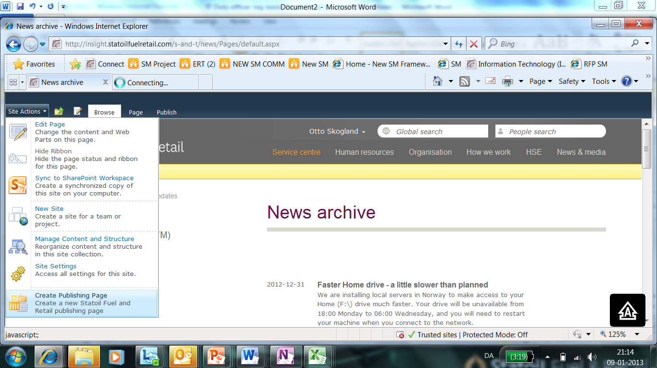

# Step 4 Create news page

1. Enter news title
2. Click Create button (bottom right) (Not displayed in screen shot below)
3. Now you have created a news page

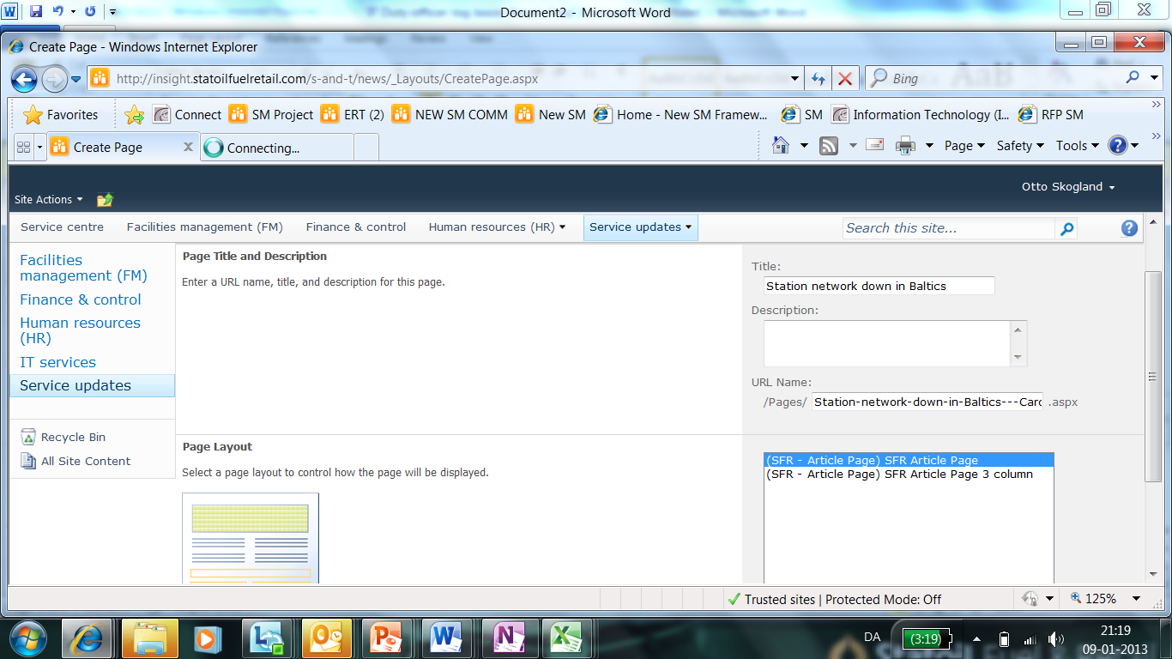

# Step 4 – Write news article

**Enter Summary text**: In the *summary* field please write no more than 255 characters (size limit). This is the intro to your article, and in some cases all your article**.**

This part will be displayed on the front page of Service Updates.

**Enter main body (May not be needed)** Information added here has no limitation in length, but is only visible when reader clicks on the article headline, and the full article is displayed on separate page.

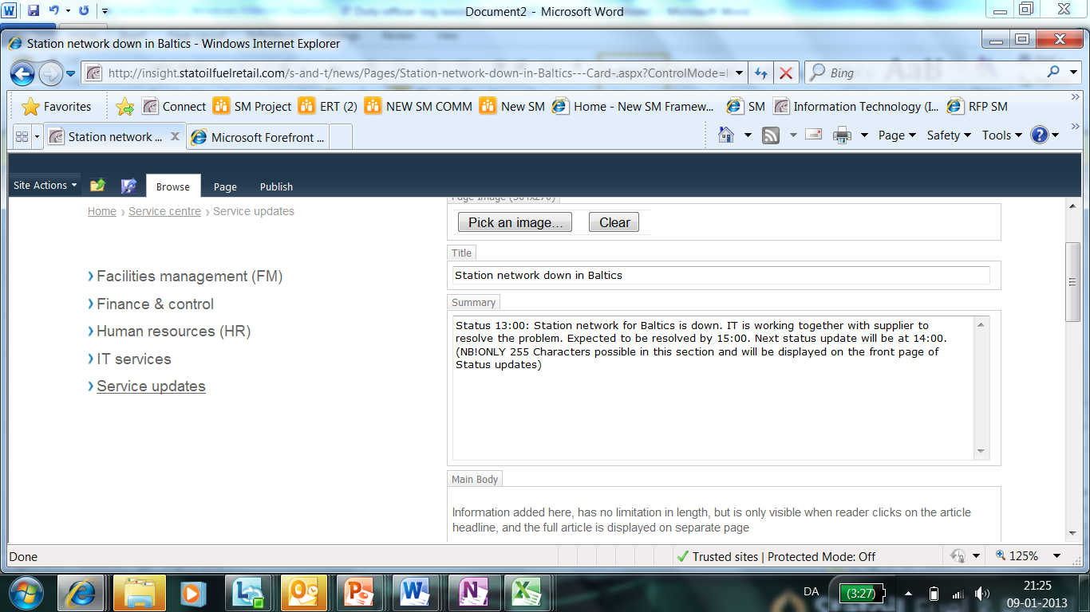

# Step 5 Publish the news

To publish, click the Publish menu item, and the publish icon.

Check Insight/Service Centre that the news has been published and looks OK.

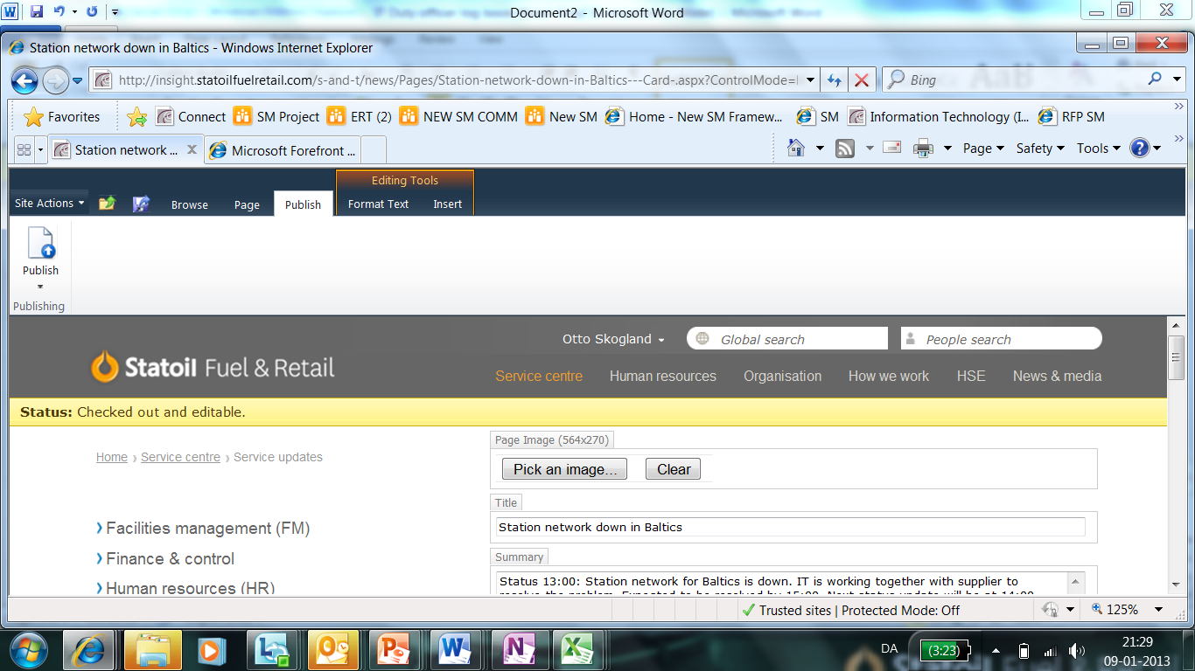

# Step 6 To Edit existing article

Click on the news article to open it on separate page, then choose Site Actions/Edit page, adjust fields as described in Step 4, and repeat Publish process. Step 5.

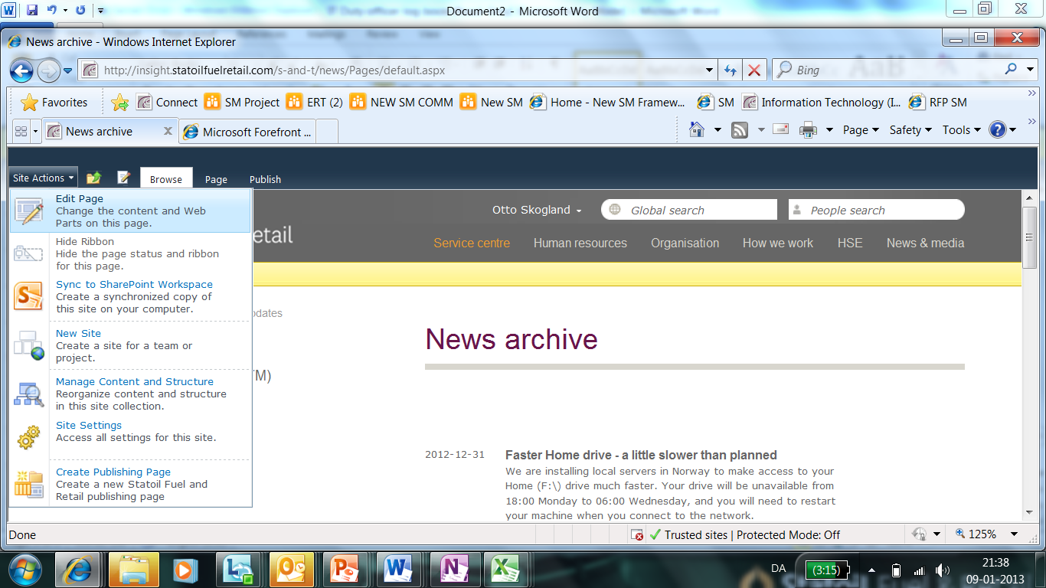

Actions:

All production outage must be reported ASAP to:

|  |  |  |  |
| --- | --- | --- | --- |
| **Europe 2nd lines** | | | |
| IT-operations | 01.04.2014 | +47 91 91 64 24 | To be notified of all incidents with actual or potential degree of seriousness of high to very high |

Link:  <http://insight.statoilfuelretail.com/HSE/ER/Pages/Emergency-Response-in-SFR.aspx>

Update service messages on insight: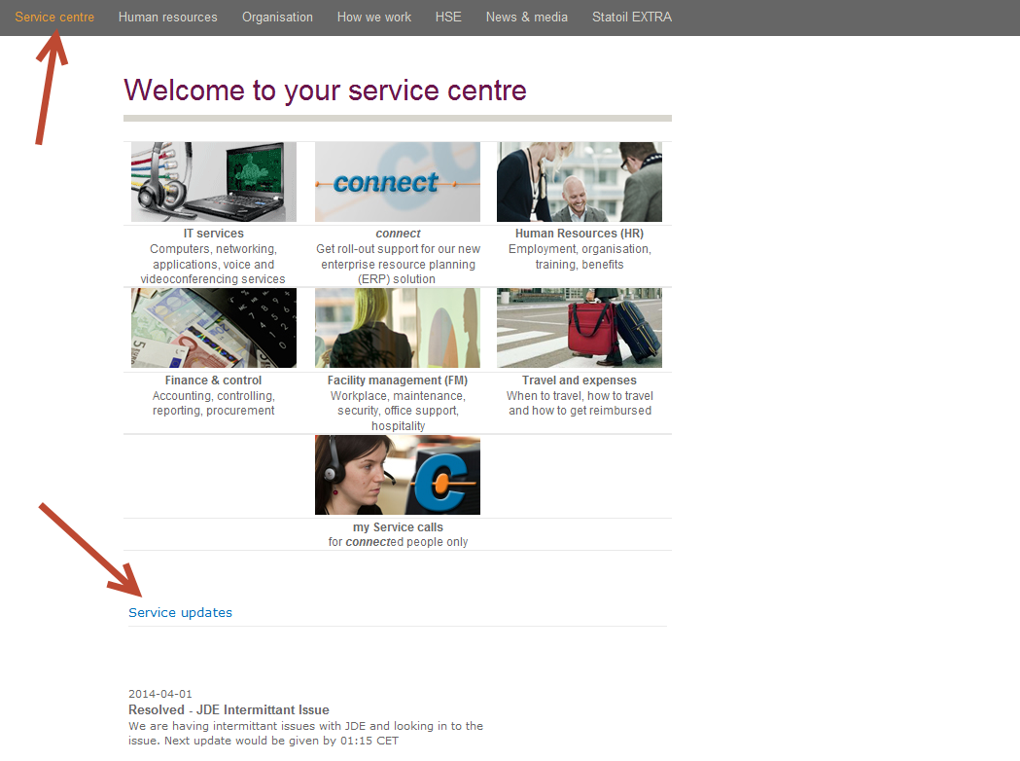

Please write to Otto Skogland for access to create and maintain service messages.

Attach how to create service message.

When the outage is solved same procedure but  keep the same sources posted with info if it takes time to solve it.

Regards

Finn